**Power BI**

**Project Report**

**on**

**ANALYSIS OF OLA BOOKINGS**

**SUBMITTED TO: Elevate Labs**

**SUBMITTED BY: Charul Manishi**

**CONTENTS**

1. Project description

2. Dataset

3. Data Cleaning

4. Output screenshots (dashboard)

5. Conclusion (Insights from analysis)

1. **PROJECT DESCRIPTION**

This project involves analyzing Ola's booking data to uncover trends and insights that can inform business decisions. By leveraging Power BI, we aim to transform raw data into interactive visualizations, facilitating a deeper understanding of booking patterns, revenue streams, and customer behaviors.

**Key Objectives:**

**Data Analysis**: Examine booking data to identify patterns and anomalies.

**Revenue Insights**: Determine top-performing months and regions based on revenue.

**Customer Behaviour**: Understand customer preferences and booking habits.

**Operational Efficiency**: Highlight areas for improvement in booking processes.

**Tools and Technologies:**

**Power BI**: For creating interactive dashboards and visualizations.

**SQL**: To query and manipulate data from the bookings dataset.

**Microsoft Excel**: For initial data cleaning and preprocessing.

**Outcomes:**

**Interactive Dashboard**: A comprehensive Power BI dashboard showcasing key metrics and trends.

**Data-Driven Insights**: Identification of peak booking periods and high-revenue regions.

**Strategic Recommendations**: Suggestions for optimizing operations based on data findings.

**Enhanced Decision-Making**: Empower stakeholders with actionable insights derived from the data.​

**2. DATASET**

**ChatGPT Prompt to Create Data**

Please create a spreadsheet with 1 lac rows, for Bengaluru city. Give the following columns. The data will be for 1 month. Use the following column:

1. Date

2. Time

3. Booking ID

4. Booking Status

5. Customer ID

6. Vehicle Type

- Auto

- Prime Plus

- Prime Sedan

- Mini

- Bike

- eBike

- Prime SUV

7. Pickup Location (Create dummy location points Take any 50 areas from Bangalore)

8. Drop Location (Take from dummy pickup locations)

9. AvgVTAT (Time taken to arrive at the vehicle)

10. Avg CTAT (Time taken to arrive the Customer)

11. Cancelled Rides by Customer

12. Reason for cancelling by Customer Driver is not moving towards pickup location---- Driver asked to cancel AC is not working (Only for 4-wheelers) Change of plans Wrong Address.

13. Cancelled Rides by Driver Personal & Car related issues-- Customer related issue The customer was coughing/sick More than permitted people in there

14. Incomplete Rides

15. Incomplete Rides Reason Customer Demand-- Vehicle Breakdown Other Issue

16. Booking Value

17. Ride Distance

18. Driver Ratings

19. Customer Rating Keep the overall booking status success for this data at 62%. If the booking status is successful, then only fare charge ratings, average VTAT, average CTAT, and other data will be there.

Make sure orders cancelled by customers should not be more than 7%

Make sure orders cancelled drivers should not be more than 18%

Also, increase the number of orders on weekends and match days.

Keep match day by using the following dates.

Keep incomplete rides less than 6%

Keep order value high on weekends in Food Category

Keep around 67 Indian

Keep order ID with 10 digits starting with CNR and then digits keep orders under 500 value 70%

Keep orders above 500 value 28%

Keep remaining orders above 1000

**Data Columns:**

1. Date

2. Time

3. Booking_ID

4. Booking_Status

5. Customer_ID

6. Vehicle_Type

7. Pickup_Location

8. Drop_Location

9. V_TAT

10. C_TAT

11. cancelled_Rides_by_Customer

12. cancelled_Rides_by_Driver

13. Incomplete_Rides

14. Incomplete_Rides_Reason

15. Booking_Value

16. Payment_Method

17. Ride_Distance

18. Driver_Ratings

19. Customer_Rating

**3. DATA CLEANING**

Tools and Techniques for Data Cleaning -

* Power BI:

Utilize Power Query Editor to perform data transformations, such as removing duplicates, handling missing values, and correcting data types.

* SQL:

Write queries to identify and correct data issues, such as using COALESCE() to handle null values.

* Excel:

Use functions and features like Remove Duplicates, Find and Replace, and data validation tools to clean data before importing into Power BI.

**4. OUTPUT SCREENSHOT (DASHBOARD)**

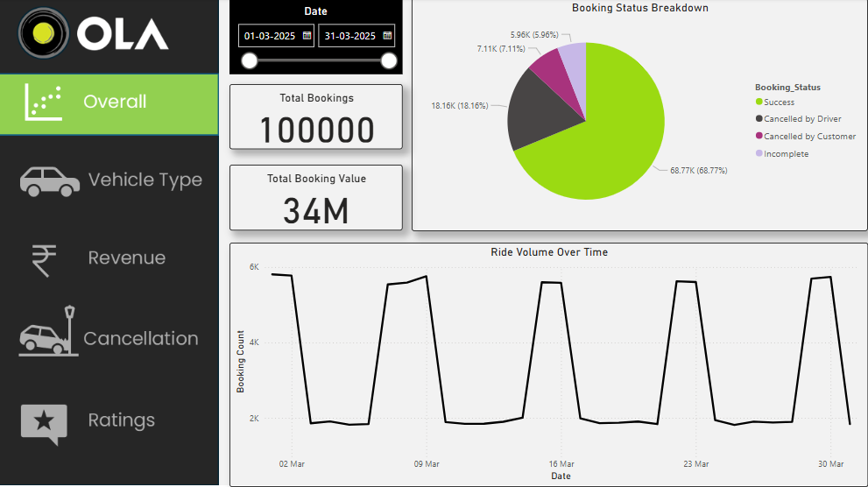

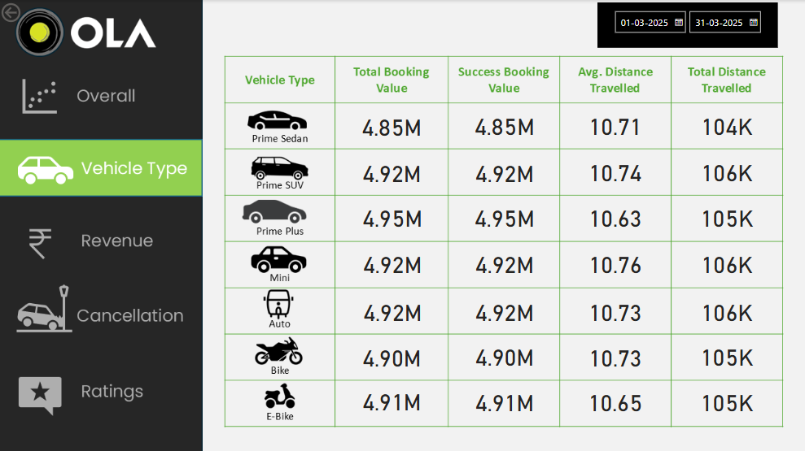

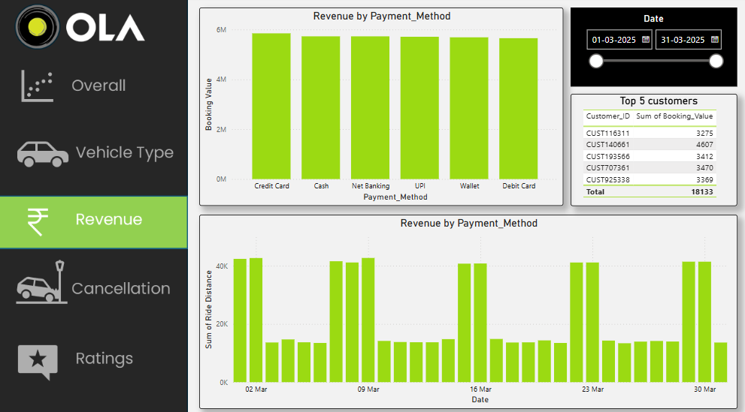

**5. CONCLUSION: INSIGHTS FROM ANALYSIS**

**1. Peak Revenue Periods**

- **Top 3 Revenue Months**: The analysis identified the months with the highest revenue, indicating peak operational periods.

- **Seasonal Trends**: A consistent increase in bookings was observed during certain months, suggesting seasonal demand patterns.

**2. Booking Status Distribution**

- **Success Rate**: A significant percentage of bookings were successful, reflecting operational efficiency.

- **Cancellation Patterns**: A notable number of cancellations were observed during specific times, indicating potential areas for service improvement.

**3. Revenue Distribution**

- **High-Performing Cities**: Certain cities consistently contributed to higher revenues, highlighting key markets.

- **Underperforming Regions**: Some regions showed lower booking volumes, suggesting opportunities for targeted marketing.

**4. Customer Behavior Insights**

- **Booking Time Preferences**: Most bookings occurred during specific hours, indicating peak demand times.

- **Preferred Vehicle Types**: Customers showed a preference for certain vehicle categories, informing fleet management decisions.

**Strategic Recommendations**

* **Optimize Peak Period Operations:** Allocate more resources during identified peak months to handle increased demand efficiently.
* **Address Cancellation Causes**: Investigate reasons behind high cancellation rates during specific periods to implement corrective measure.
* **Focus on High-Performing Markets**: Invest in marketing and infrastructure in cities contributing significantly to revenue.
* **Enhance Customer Experience**: Tailor services based on customer preferences, such as preferred booking times and vehicle types, to improve satisfaction.

By implementing these strategies, Ola can enhance operational efficiency, customer satisfaction, and overall profitability.